An FTP (File Transfer Protocol) server is often used for data exchanges in many data integration scenarios. SSIS includes an FTP task to download and upload data files to and from an FTP location

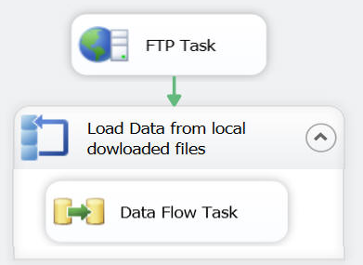

|  |  |
| --- | --- |
| **Operation** | **Description** |
| Send files | Used for uploading files from the local machine to the FTP server |
| Receive files | Used for downloading files from the FTP server to the local machine |
| Create local directory | Used to create a folder on the local machine |
| Create remote directory | Used to creates a folder on the FTP server |
| Remove local directory | Used to delete a folder on the local machine |
| Remove remote directory | Used to delete a folder on the FTP server |
| Delete local files | Used to delete a file on the local machine |
| Delete remote files | Used to delete a file on the FTP server |

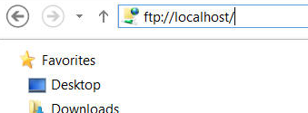

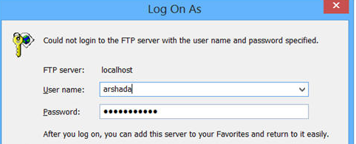

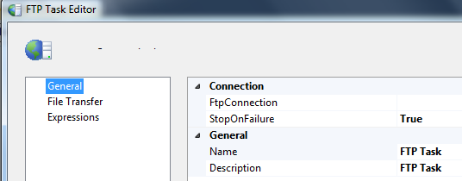

Set FtpConnection

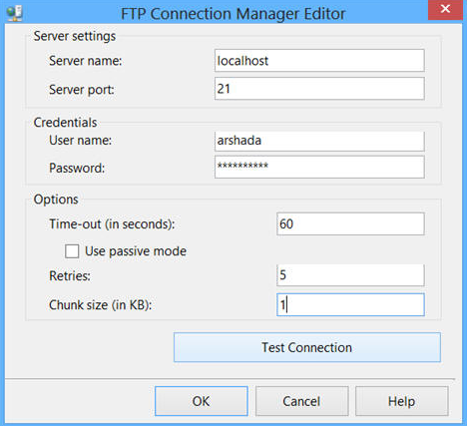

Set

* LocalPath: **Set Folder**
* Operation: **Send Files**
* RemovePath set **/\*.txt** for a group, or set the specific file

**Downloading Multiple Files using a Wild Card Character**

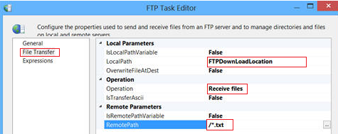

We can use the **ForEach Loop Container** with a **ForEach File Enumerator** and process all the data files from the locally downloaded folder; in other words, process each data file one at a time in a loop.

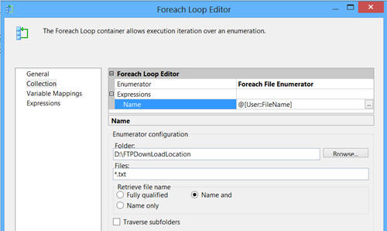

The FTP Task in SSIS does not support SFTP (Secured FTP), but there is a task available at [codeplex](http://ssissftp.codeplex.com/" \t "_blank) which can be used for this scenario.